9

Two toy cars, black and brown, are having a race.

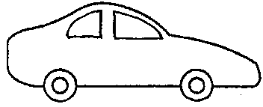
START
black
brown
15 metres
9 metres

The black car travels 9 metres in 3 seconds.
The blue car travels 15 metres in 5 seconds.

(a) Which car was faster?

Tick ONE box ()

❑ | The black car.
❑ | The brown car.
❑ | Both had the same speed.

(b) Explain your answer: _______________________________________

______________________________________________________________

______________________________________________________________

______________________________________________________________

